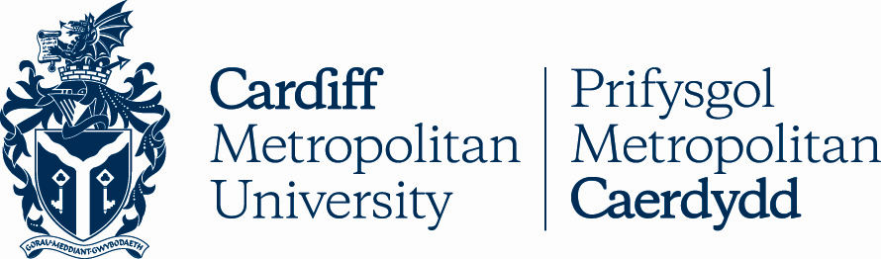

Qualification Reforms 2017:

Cardiff Metropolitan University is aware that qualifications are changing in Wales and England from 2015 onwards, and we aim to be as flexible as possible during this transitional period so as not to disadvantage applicants. The University will accept the new GCSE and A Level qualifications, and offers will reflect the new reforms. Cardiff Met is currently reviewing Programme entry requirements for 2017 and offers will continue to be made on an equivalent basis to current qualifications.

Some adjustments to subject requirements may need to be made for individual Programmes - our website will be updated to reflect any changes.

GCSE
- We appreciate that some students may be applying for University over the next few years with a combination of old and new style GCSEs, and we will not discriminate against this.
- We will continue to expect applicants to have achieved a minimum of 5 GCSEs (A*-C or 9-4) or equivalent, to include Maths and English Language.
- For 2017 entry, we will ask applicants who have sat GCSEs in England to achieve a minimum Grade 4 as an equivalent to GCSE Grade C. (Please note some programmes require a B Grade in Maths and English Language and the grading equivalency will be determined shortly)
- We will soon be formalising which courses will require students from Wales to achieve both GCSE Mathematics-Numeracy and GCSE Mathematics.

AS Levels
- For 2017 entry, the AS Level will be worth 40% of an A Level. In Wales, the AS level will remain embedded in the A Level; in England, the AS Level will be decoupled from the A Level as A Levels become linear. We will not discriminate against applicants who are not undertaking AS levels and will continue to take the whole application into consideration.
- For students who have undertaken AS levels, we will not be considering 2 AS Levels as an equivalent to 1 A Level.

Extended Project
- The Extended Project qualification will continue to be considered by the University and we welcome the additional breadth of study this qualification brings.

A Levels/Welsh Baccalaureate Advanced Diploma
- We appreciate that some applicants may be applying for programmes with a mixture of old and new style A Levels, and we will not discriminate against this.
- We will continue to expect applicants to undertake 3 A Levels (or equivalent) and offers will be based on this. For students undertaking the Welsh Baccalaureate Advanced Diploma, offers will continue to be based on 2 A Levels and the Welsh Baccalaureate.
- For 2017 entry, applicants undertaking the Welsh Baccalaureate Advanced Diploma will receive offers requesting a specific grade in the Welsh Baccalaureate.

