Thinking of going to uni?

Higher education (HE) gives you the opportunity to expand your knowledge on a subject you’re passionate about, or help you work towards the job of your dreams. However, it’s not just about learning – it’s a great experience and helps you to develop the essential skills and knowledge that you will need for your future working life. Higher education qualifications are internationally recognised, and there is plenty of evidence that graduates have increased earning potential – but you do need to be motivated to study and learn.
The first thing to do, if you haven’t already, is make sure you sign up to your UCAS Hub.

Your UCAS Hub will give you all the tools and information you need – in one place. We can then guide you to the information you need. You can easily explore, filter, and favourite the things which matter to you most.
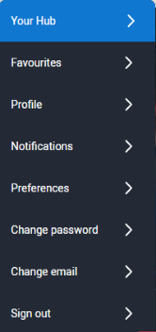
How do I sign up?
The UCAS Hub is free and easy to use. All you need to do is follow these three simple steps to sign up:
Step 1 – Register
To get started, visit ucas.com/hub.
Step 2 – Verify your account
Once you’ve completed your registration details you’ll be asked to verify your account by entering a code we’ve emailed you.
All you need to do is copy the code from the email and hit the verify button
Step 3 – Sign in
Now you’re ready to sign in and start exploring! The first time you do, we’ll ask you some extra questions so we can help you find the right info.
At any time to pick up where you left off, click ‘Sign in’ on the top right-hand side of any page on ucas.com, and navigate to ‘Your hub’.

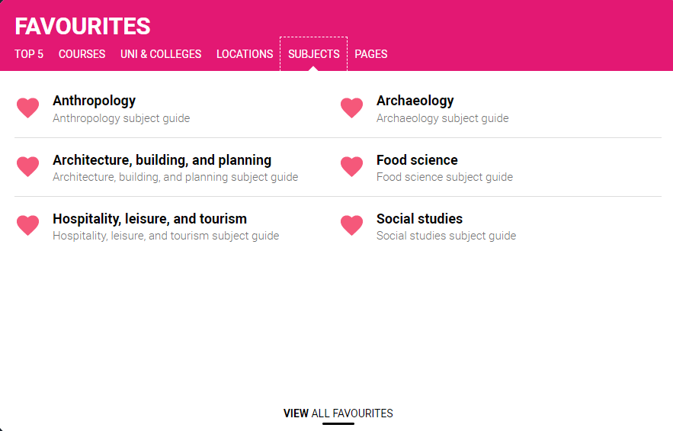
UCAS hub top tip:
Favourite while you explore – the more you favourite the more suggestions we can make.
Simply click on the heart icon (usually top right-hand corner) – then you can come back to it easily at any time.
Favourite universities, colleges, courses, or regions to help you work out what is right for you and explore further.

Activity 1: Explore, explore, explore

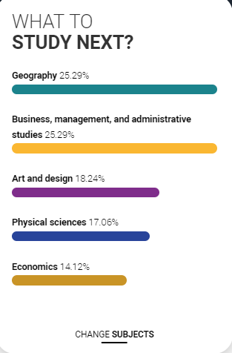
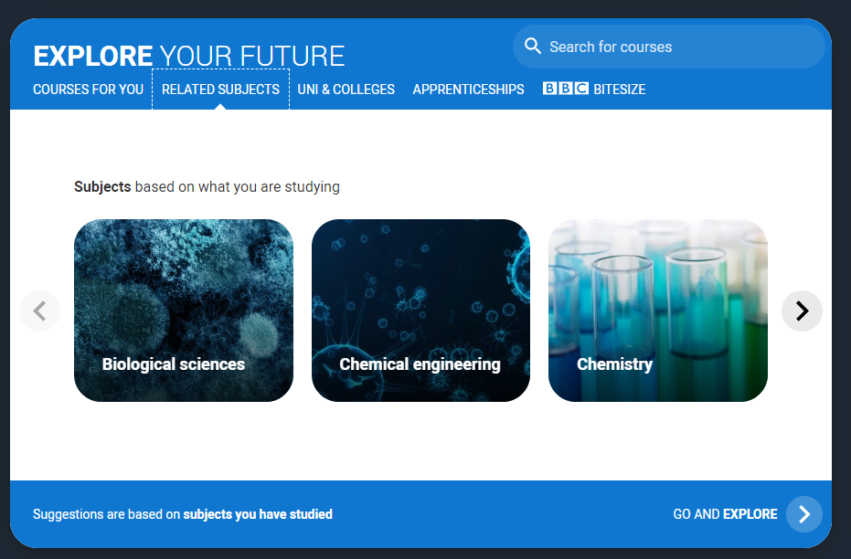
Think about your favourite subject or the fact you might find something entirely new. You might have a specific career goal in mind. Or you might still be unsure.
The best place to start is with an open mind. This will help you understand if what you’re studying might be a good fit, and to check if you need any specific subjects or qualifications for your career goals.
- Explore: ‘Go and Explore’ our detailed subject guides – suggestions are made based on the subjects you are currently studying, but you can favourite any others you’re interested in too. These will give you a description of:
- what the subject is all about
- entry requirements
- what you can do with a degree in the subject
- what it’s like to study
- apprenticeships that also might be available

- What to study next?: Use our tool to give you some inspiration. It will give you some idea of what people like you applied for. Use the information to help you explore new ideas. Explore more about each one through the subject guides, explore related courses, and add to your favourites.

Activity 2: Life in higher education – what’s important to you?

Along with thinking about the type of subject you might like to study, it’s important to think about how uni or college will fit with you. The reality is no one place is ‘best’ for everyone. You need to consider the type of university you want to attend – the experience can vary enormously.
Here are some things to consider. Make a note of your responses to some of these questions so you can come back to this when you’re doing more detailed research on your course choices. Our city guides are a great start to get you thinking about locations, costs, and experiences.
Factor | Things to think about | What is important to you?
Style and size | Universities can have a focus on subject-based courses and research, or a greater focus on vocational courses. Do you have a preference?  Do you want to study at a campus university (all in one place) or one that is spread out across a town/city with different locations?  Some larger universities can have more than 20,000 students, whereas some of the smallest have only a few thousand. What would suit you best?  Would distance learning or part-time study fit your situation?
Location | Some are based in large cities, others in smaller towns. This can have a major influence on the environment and lifestyle on offer.  Do you want to live at home? If not, how far away do you want to be?  Would you rather be in a city, countryside, or near the sea? Is the local surrounding area important? What would you like to have access to? E.g. museums, nightlife, walks, parks.  How will you travel around? Do you want to take a car? Will you need access to a train station/airport?
Culture and facilities | This can be influenced by a range of factors, including the diversity of students who attend.  What teams, clubs or societies could you take part in? Can you pursue a current hobby or interest?  Are the facilities important to you? What would you like to access? E.g. library, sporting facilities, students’ union.  Are there any specialist services you need access to?
Graduate and career services | All universities collect destination statistics (where students go on to). It can be interesting to find out the types of jobs or further study students chose.  Is it important that they offer comprehensive career services? E.g. interview training help with job applications.  Do you want the opportunity to have a placement year or internship opportunity?  What about the chance to study abroad?
Costs | Tuition fees can vary between course providers. How might you pay for university? Would you be looking for a scholarship or bursary?  What type of accommodation would you like? Halls of residence? Off campus living? Shared? Think about longer term too, not just your first year when you might be in student halls.  How will you travel to and from lectures? Would this influence the type of accommodation you would like?  What transport options are there? Would you be able to take a car (if that’s important to you)?  Think about other costs you might have – such as socialising, food, clothes, study materials. Different regions of the country will vary in cost.

Activity 3: So, what’s uni really like?
Hopefully you should now have a rough idea of what you might be interested in studying and what’s important to you. Now it’s time to find out more. Try to tick off each of the suggestions below – they’ll help you make the right decisions.
Remember to use what you have identified as important to you in previous activities as a guide. Events and open days are great if you prepare for them.
- Open days – one of the best ways to explore the unis and colleges themselves is to visit in person. You get a feel for what it would be like to study there, ask questions, and go to talks on your subject areas. Use our events search tool to check dates and sign up to visit the unis and colleges you’re interested in most.

- Virtual open days – these will involve different things such as live chats, virtual subject booths, virtual taster days, webinars, and more. It’s a great opportunity to visit as many universities and colleges as you can without having to do all the travel. So, book onto a couple to find out what university might be like. Don’t worry about specific courses at this stage (unless you know), it’s about working out if higher education is right for you.

- UCAS Discovery – come to a UCAS Discovery event – we have both in-person and online events. They are a great way to start thinking about what path might be right for you. Online events have a great ‘Live Lounge’ line-up and area, available on-demand. Our in-person exhibitions give you the chance to speak to hundreds of unis and colleges face-to-face.
- Unibuddy – a great way to learn more about what uni life is really like from current students. You can choose a uni, degree subject, or the student’s home country. Ask the ambassadors anything and learn more about why they chose to do their specific course at that specific university. Chat to students through your UCAS Hub.

- Virtual tours – take a virtual tour so you can see what it’s like on campus and what facilities are available. Now is the time to really do your research. You’re not limited to the number of tours you can take, so explore as many as possible. If the uni/college you're interested in isn't listed, take a look at their website or YouTube channel instead, or see if they're on Unibuddy.

- Social media – check out uni and college social feeds. Many are promoting live chats, subject webinars, and extra info to help students find out more.

UCAS hub top tip

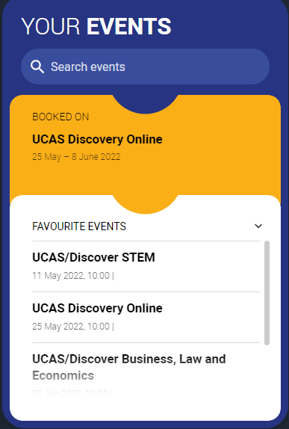
You can set the ‘Events’ tool in your Hub to show events near you, or at unis and colleges you’ve favourited. Don’t forget to use our events search to find more. Use the filters to show you digital events, different locations, and our UCAS Discovery exhibitions. Remember to favourite those events to then easily refer to them from the events tool in your Hub.

Plan for any open days, events or tours you’re going to. Who do you want to speak to? What questions do you want answered? What do you want to get out of the experience? See our advice, including our 10 questions series.

