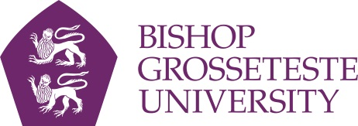

Statement on A level and GCSE Reform in England

Bishop Grosseteste University is committed to providing a fair, transparent and consistent admissions service for applicants who apply nationally or internationally.

We recognise that planned changes to the 16-19 curriculum will mean that, from 2017 entry onwards, the opportunities open to students to take combinations of A and AS level examinations will vary from school to school and college to college.

We will continue to take into account all the information on an applicant’s UCAS form to make a judgement as set out in pre-determined selection criteria; particular notice will be taken regarding the year of qualification so as not to disadvantage any individuals. We have evaluated our entry requirements for 2017 entry and to demonstrate our inclusivity, most subject areas have lifted the subject-specific requirement at Level 3.

In many cases we do not require subject specific GCSEs. However, where GCSEs are a requirement, we will expect applicants to achieve a grade 4 or above under the reformed GCSEs.

We welcome applicants with a wide range of qualifications such A-Levels, BTEC National qualifications, International Baccalaureate (IB) Diploma and Access to Higher Education course to name a few.

We will continue to monitor developments in the curriculum changes across the UK, working closely with UCAS and Supporting Professionalism in Admissions (SPA) and will update our guidance and requirements accordingly. We will not, however, amend our entry requirements mid-cycle as a result of any qualification reform.

We will continue to consult Teachers and Advisers in Schools and Colleges and if there are any initial queries, please do not hesitate to contact the Admissions Office on [admissions@bishopg.ac.uk](mailto:admissions@bishopg.ac.uk) or 01522 583658.