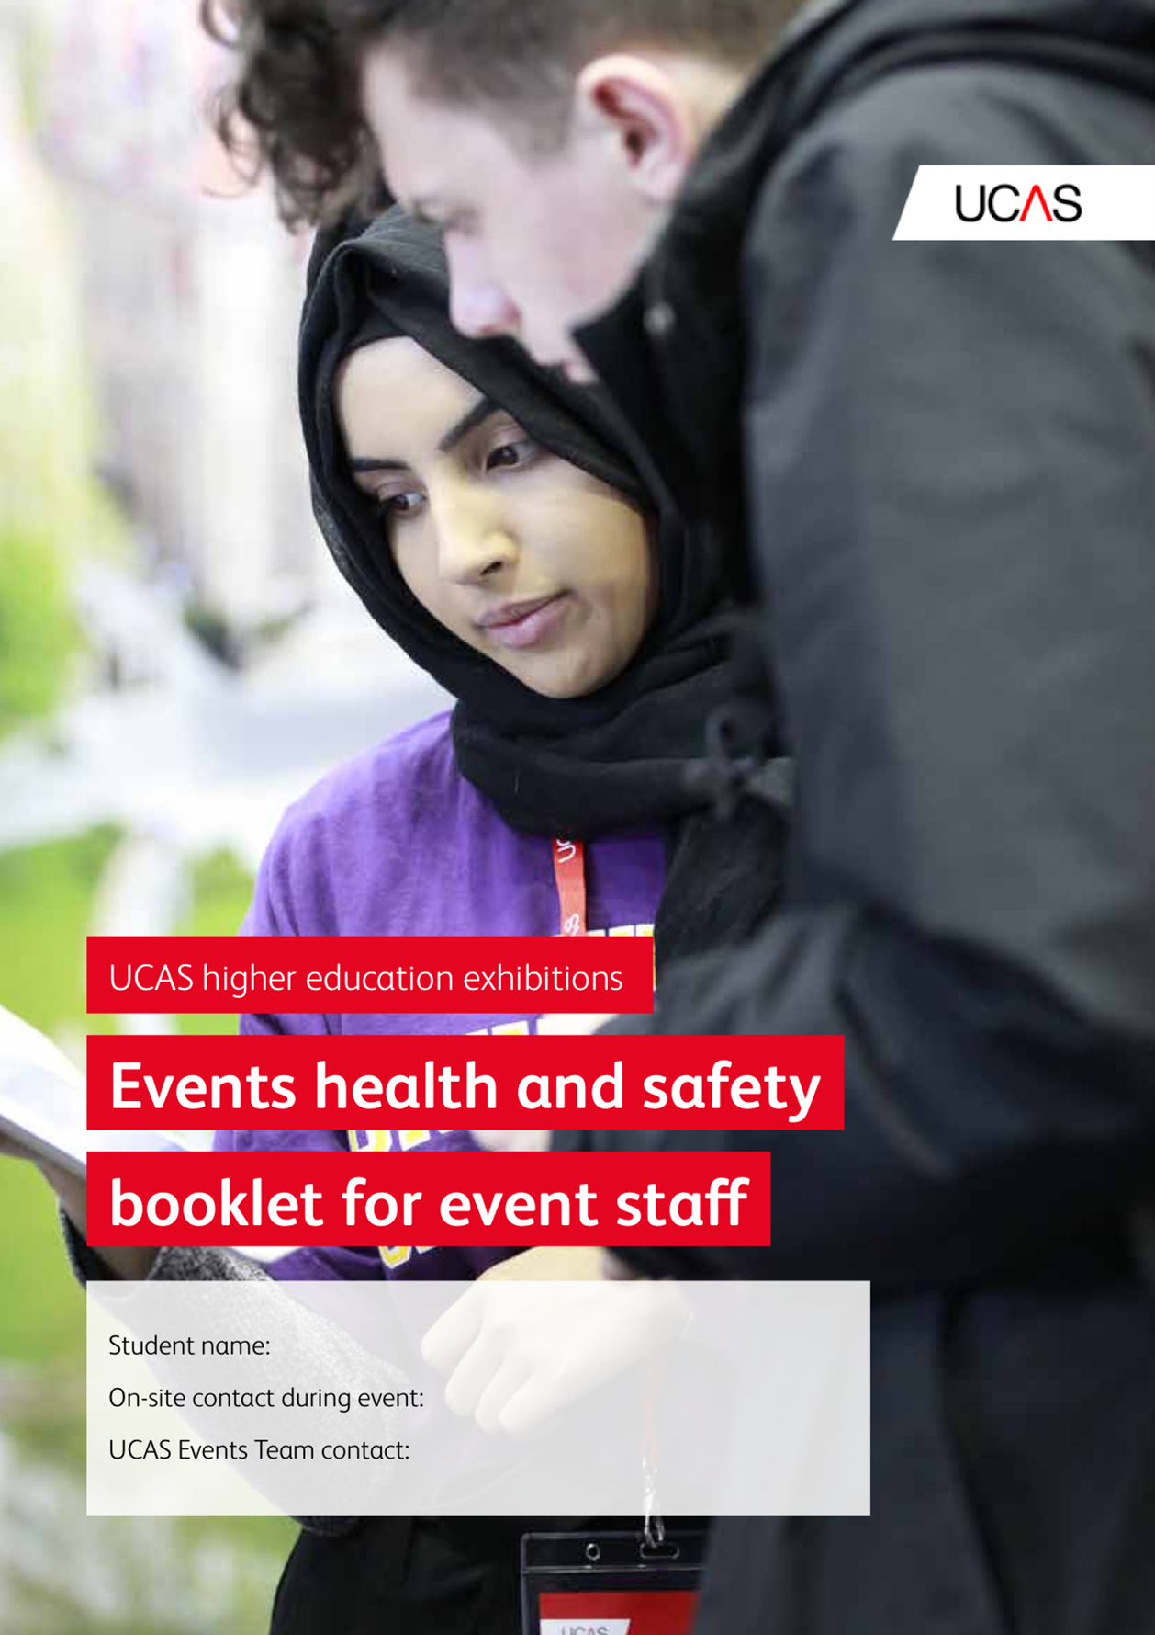

Contents

Near miss and accident reporting 3
Arrangements for first aid 3
Fire and emergency evacuation 3
Work equipment and vehicles 3
Manual handling 4
Electricity at work 4
Safety signage 4
Personal protective equipment (PPE) ………………………………………………………………………………………………….5
Phased on-site work schedule 5
Code of conduct for event staff at UCAS higher education exhibitions 8

Near miss and accident reporting

A ‘near miss’ is an incident that doesn’t result in personal injury – it’s purely luck that it didn’t, and next time, the person involved might not be so lucky! Research has shown there is a clear link between near misses and accidents. Reporting near misses or unsafe conditions can help prevent accidents, and promote a safer working environment – not just for employees, but anyone who visits the site. Data compiled from near misses and accident reports can help to highlight trends and hazards previously unidentified.

Please report any incident or near miss to the event organiser.

Arrangements for first aid

Provisions are in place for first aid arrangements. The location of the first aid point is identified on the map included in this pack. Please ensure you are aware of the first aid point, and can direct people, if asked.

If anyone requires first aid treatment, please alert a qualified first aider at the first aid point or organiser’s office.

Fire and emergency evacuation

You need to be familiar with the procedures in the event of a fire, or if the site needs to be evacuated due to an emergency. If you discover a fire, you must raise the alarm immediately, and exit the building as quickly and safely as possible. Do not retrieve personal belongings from the site. Entry back into the building is only permitted when advised by the fire officer or site manager.

Hazards associated with fire include burns, smoke, toxic fumes, and suffocation.

Do not attempt to fight the fire yourself. Make your way to your assembly point for a roll call.

Work equipment and vehicles

There are many different types of equipment used, for a variety of tasks. Work equipment can include things as simple as a bucket, which is relatively low risk, to construction equipment, which is of higher risk. All work equipment presents hazards, and the potential to cause harm if not used properly for the intended purpose. Some common hazards associated with work

equipment can lead to substantial injuries including trapping, entanglement, contact, ejection, and impact.

Never use work equipment on-site unless you have been authorised and trained to use it.

Be aware of moving vehicles on-site during set-up and breakdown of events.

Manual handling

Many jobs involve some kind of manual handling, which doesn’t necessarily mean just lifting. Pushing, pulling, and supporting are all forms of manual handling, and the correct techniques need to be employed for your safety.
- Stop and think – plan the lift.
- Assess the load and environment – seek assistance if required.
- Are mechanical aids available to assist?
- Can the load be broken down into more manageable weights?
- Position your body: feet shoulder-width apart close to the load, with your strongest foot forward.
- Adopt good posture, unlock the knees.
- Keep your body close to the load, and with a firm grip, lift smoothly, using your legs , not your back.
- Avoid twisting and stooping, and pivot using your feet.

Electricity at work

Electricity can cause burns, electric shock, and fire, and has the potential to kill, so you need to be cautious.

Never use faulty electrical equipment, report it to the event organiser immediately.

Do not tamper with electrical equipment.

Do not bring electrical equipment onto the premises for use.

Safety signage

There are many signs on the premises highlighting important information and requirements, to ensure your safety. You need to be familiar with these signs, and understand their meaning.

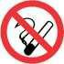
Prohibition sign – prohibits behaviour likely to increase or cause danger (e.g. no
smoking).


Warning sign – gives warning of a hazard or danger (e.g. danger: forklift trucks).

 Mandatory sign – prescribes specific behaviour.

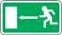 Safe conditions sign – gives information on emergency exits, first aid, or rescue facilities (e.g. emergency exit or escape route).

Personal protective equipment (PPE)

Please be aware, while on-site at events, some tasks will require certain contractors and event staff to use PPE. During set-up and breakdown, tasks requiring PPE should have been completed before you arrive, and not before you leave. However, please be aware there may be situations when this is unavoidable. The organisers will do their utmost to isolate you from areas where build-up or breakdown is taking place, but please be vigilant and aware of what is happening around you.

Phased on-site work schedule

Follow instructions, and keep to designated work areas.
After your site induction, all instruction of tasks during set-up and breakdown periods should come from UCAS staff, or appointed site teaching staff only.
Phase | Task | Applies to | Start time | Projected completion time
Set-up | Construction and fitting out | Construction and fitting out | 08:00 | 15:00
 | Construction sign-off | Construction sign-off | 15:00 | 15:00
 | Construction phase finished | Announced by event organiser | 15:30 | 17:00
 | Installation of tables and chairs, prepare stands | Event staff | 15:00 | 17:00
 | Exhibitor set-up | Exhibitors and event staff | 16:00 | 18:00
Open exhibition | Morning set-up phase for exhibitors | Organiser and event staff | 08:00 | 09:00
 | Set-up phase finished  Under no circumstances should the use of lifting equipment or deliveries on trolleys for the event floor take place once the event has opened to the public | All | 09:30 | 15:00
Breakdown (day 2) | Exhibitor breakdown | Exhibitors | 13:30/14:30/15:00 | 16:00
 | Clearing of stands, including tables and chairs, and general clean and tidy | Event staff | 13:30/14:30/  15:00 | 16:00
 | Dissemble and removal of stands – PPE area only | Contractors | 16:00 | 18:00

Key:

Red – access to site only for event organisers and contractors. PPE to be worn. Venue in build status

Orange – access to site only for event organisers, contractors, and event staff. Hi-vis clothing to be worn if contractors still working. Proceed with caution

Green – event safe, open to the public
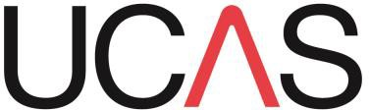

Code of conduct for event staff at UCAS higher education exhibitions

- Arrive early, so you’re ready to start working at the time stated.
- You can only leave once given permission by the event organiser.
- You must wear the supplied red UCAS t-shirt while on duty, with dark jeans or trousers, and comfortable shoes. If the area you are in is cold, please wear the red t-shirt over any extra layers, so you remain easily identifiable. Please cover up your t-shirt while off duty, such as on breaks, and before and at the end of your shift. This is primarily to ensure you do not have to deal with any queries when you’re not working.
- By wearing the t-shirt, you will be seen by exhibitors and visitors as a member of UCAS event staff, and ready to respond to queries. As you are under employment by UCAS, you should behave in a respectable and appropriate manner. Make sure you are always alert, ready to help, and look professional.
- Do not interrupt exhibitor conversations unless urgent. If you need to talk to an exhibitor, please wait for an appropriate time to intervene.
- While everyone will be given a task to perform throughout the day, you may be required to
do ‘odd jobs’ by the organiser, as and when needed.
- You must always help exhibitors and visitors where requested, within reason, and without compromising your main allocated duties. If you are uncertain about a task you have been asked to do, please ask the event organiser for advice.
- You should not look after a stand for an exhibitor at any time – for example, while they take a break or have lunch. It is the exhibitor’s responsibility to make sure their stand is staffed by their own representatives, at all times.
- Know what time your lunch is, and keep to that time. There are a lot of staff who need to take a break, and assist with the smooth running of the event. So, only go on lunch when someone has arrived to take over your duty. Bear in mind, others will not be able to go for their break until you return, so please keep to your allotted times.
- Handouts and giveaways are for registered visitors only. You are not permitted to ask exhibitors for any.
- Do not lift items if you are unsure about the weight of the object. Please refer to the manual handling section in this health and safety booklet.
- If given a radio to communicate with, you must talk professionally when using them.
- You should not collect any exhibitor scanners on their behalf, nor return them. Exhibitors are responsible for the scanners they have booked.

Make your notes here:

