

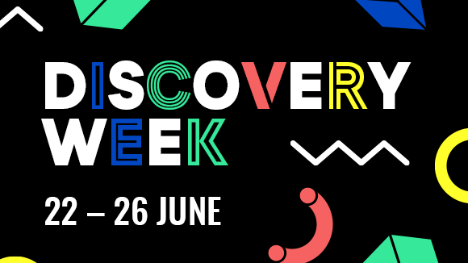

Your invitation to UCAS/Discovery Week 22 – 26 June.
Help your child explore a world of possibilities after school or college and get one step closer to planning their next adventure.
This June, we’re bringing you and the person you’re supporting a whole lot of inspiration, information and live sessions! Everything they need to get ahead this summer and keep moving forward with their plans after school or college – all packed into one week-long UCAS/Discovery event.
From live application clinics and personal statement workshops to an entire showcase of post-18 and career opportunities. Students can join online and easily find the answers they need.

To save your virtual seats, please register individually here. You’ll then be sent information about the event and how to join live on the day, or watch on-demand.

Book now >

For more information, visit ucas.com/virtual-exhibitions

